**Lesson Demo**

**Exporting Data**

**Business Scenario:**

One of leading consumer products and services companies uses Tableau to analyze a large amount of data on retail behavior, sales and profit, procurement of key inputs, and so on. This helps in gaining detailed insights into the company’s performance. Now, they intend to send some of this information to their clients. As their clients are not familiar with Tableau, they need to send the views generated in some other format. These requirements can be met by publishing the views in the PDF format.

# Overview:

* Open the **Lesson 12 Exercise** workbook
* Copy records from the Region and State Analysis View into Microsoft Excel
* Export the Profit by State Graph as an image
* Export records from Sales and Profit by Subcategory Graph to an Access file
* Export the entire workbook to PDF

**Detailed Instructions:**

1. Under the **Start** menu, point to **All Programs,** and select **Tableau 10.2**

1. To open a workbook, under the **File** menu, select **Open**

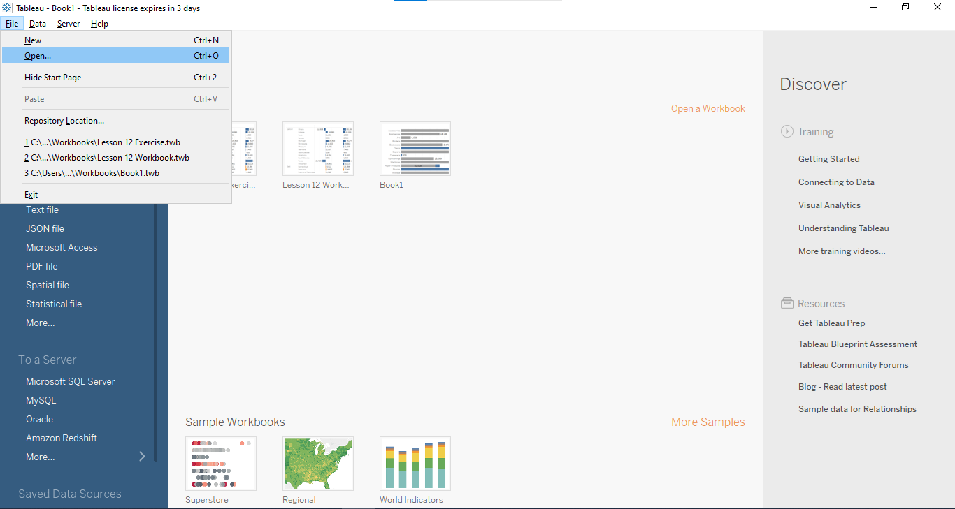

1. In the Open window, browse **Documents\My Tableau Repository\Workbooks** and select the **Lesson 12 Exercise** workbook

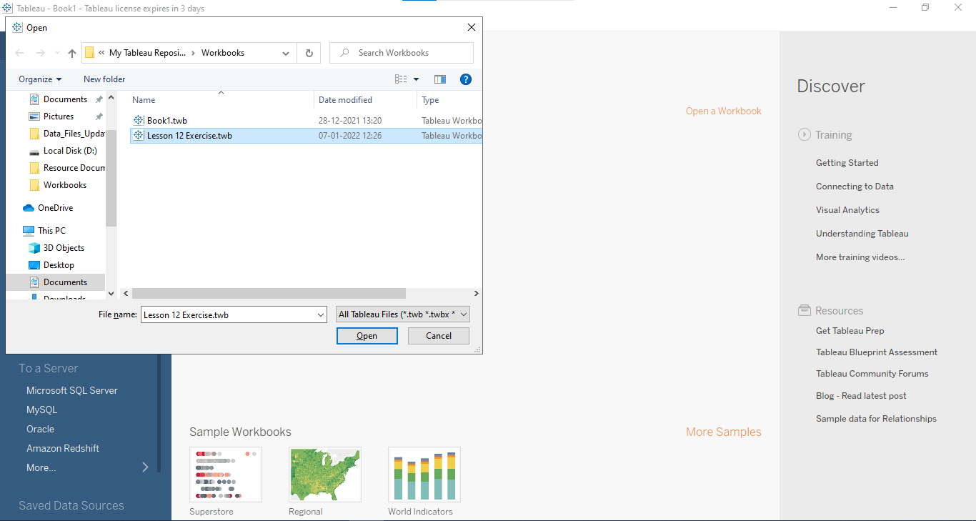

1. Open the **Region and State Analysis** sheet

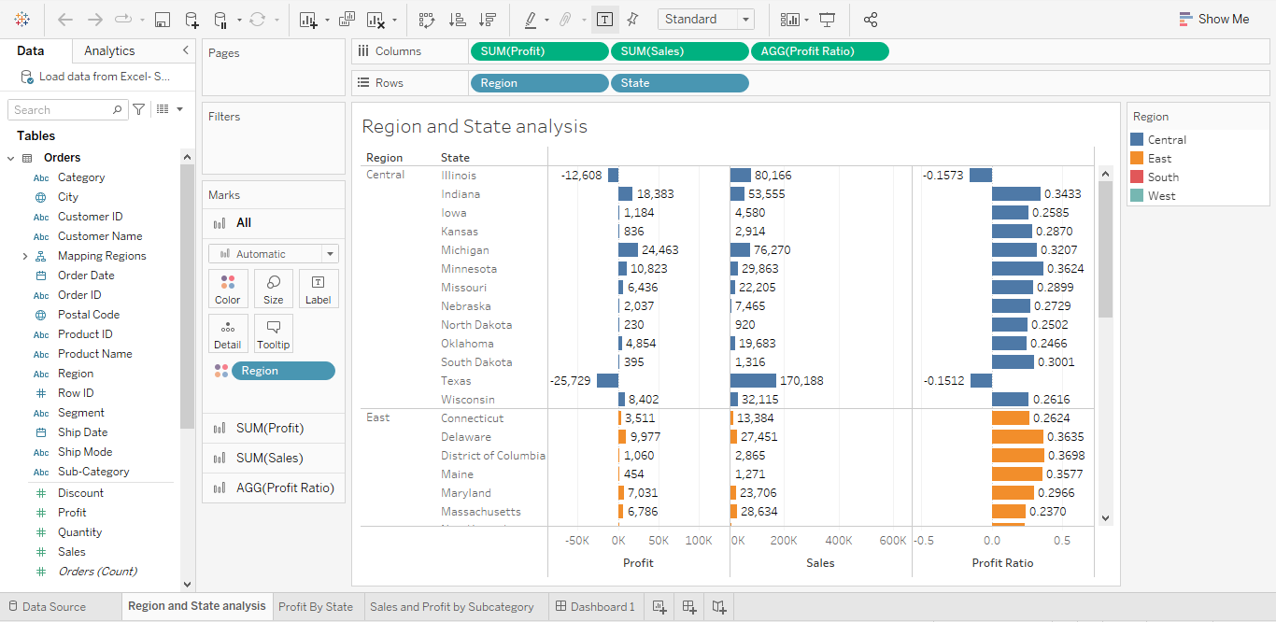

1. To copy records to excel, under the Worksheet menu, go to **Copy**, and select **Crosstab to Excel**

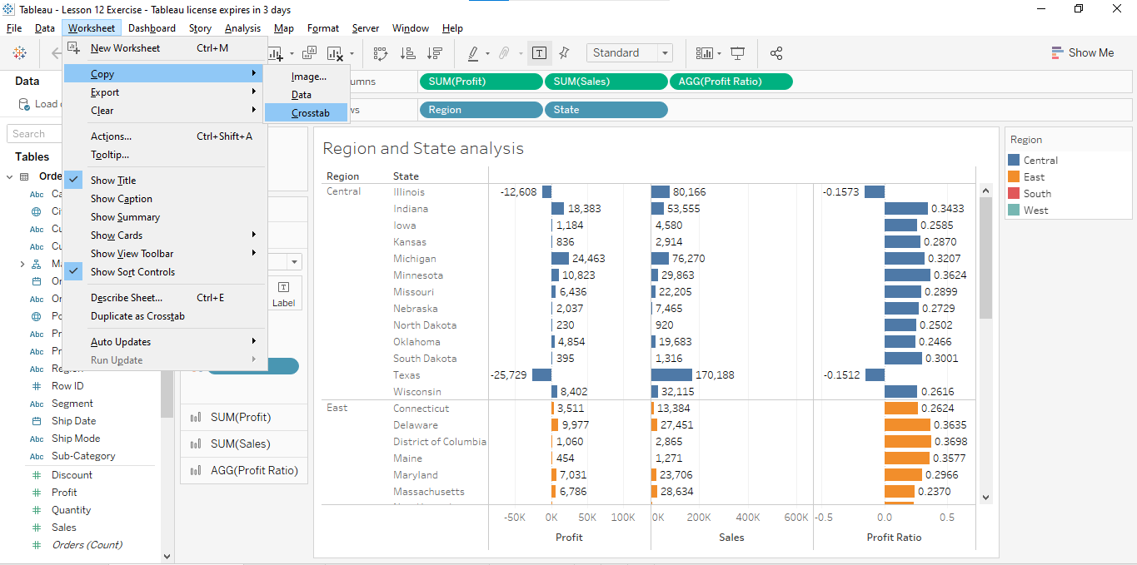

1. Open the **Profit by State** sheet

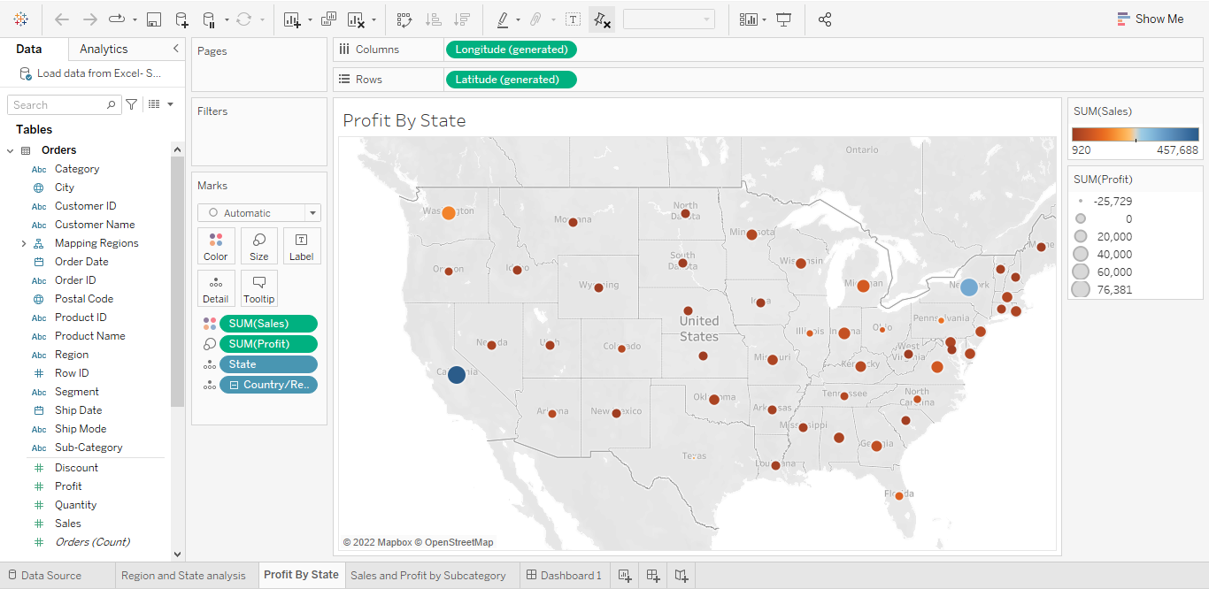

1. To export as an image, under the Worksheet menu, go to **Export** and select **Image**

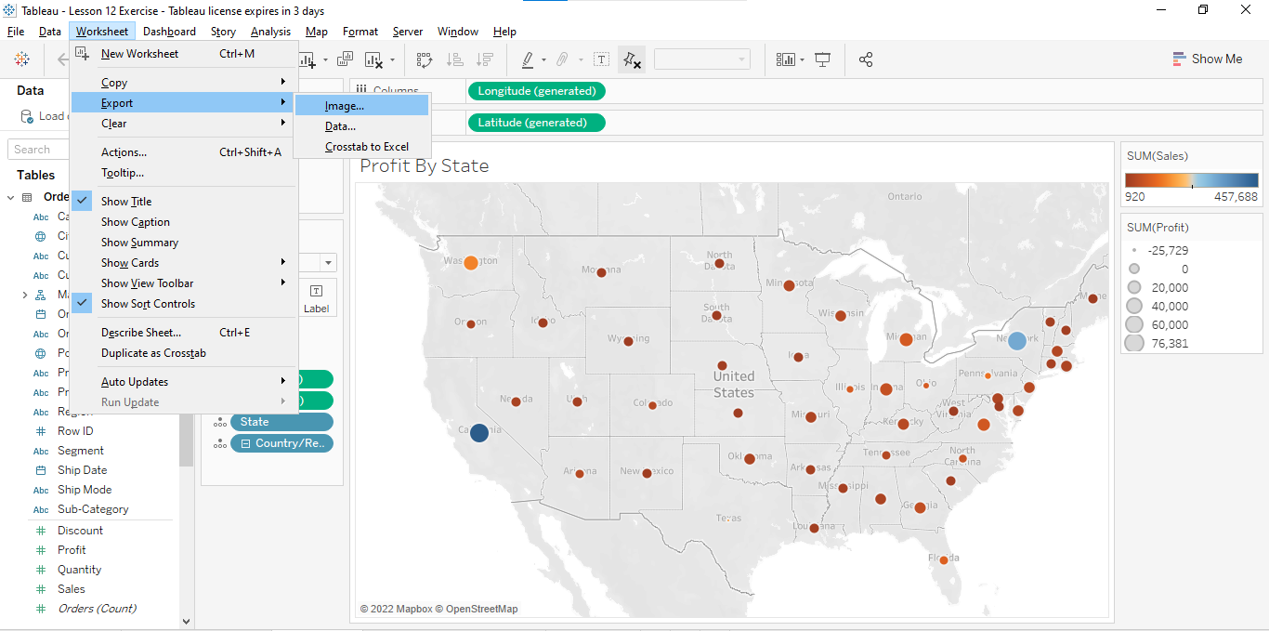

1. Save the jpg image on your system

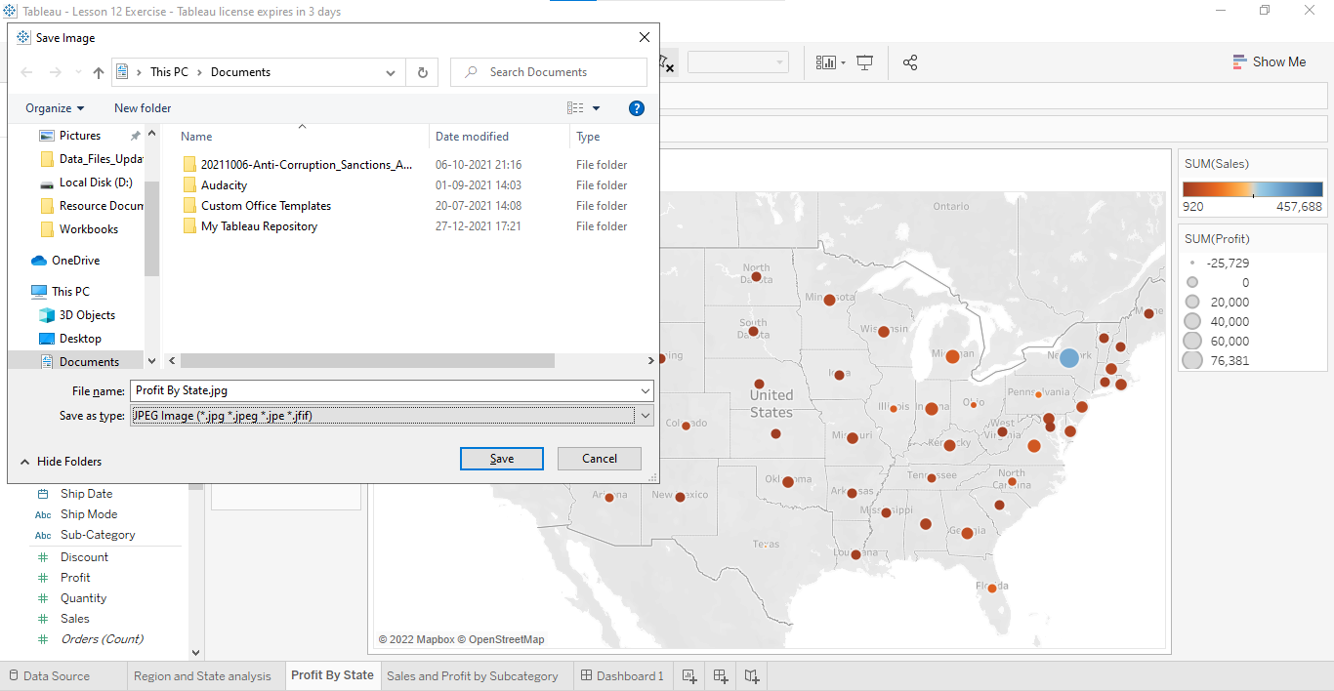

1. Open the **Sales and Profit by Subcategory** graph

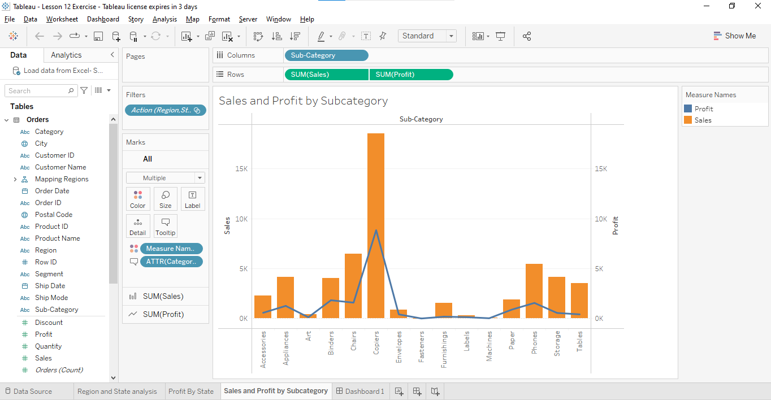

1. To export records as an access file, under the Worksheet menu, go to **Export** and select **Data.** Save the Access file on your system

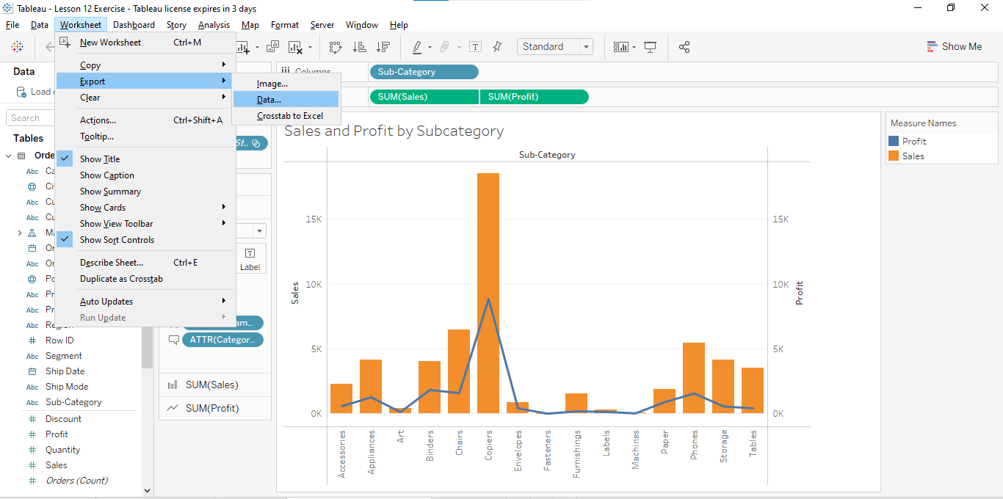

1. To publish as PDF, on the **File** menu, select **Print to PDF**

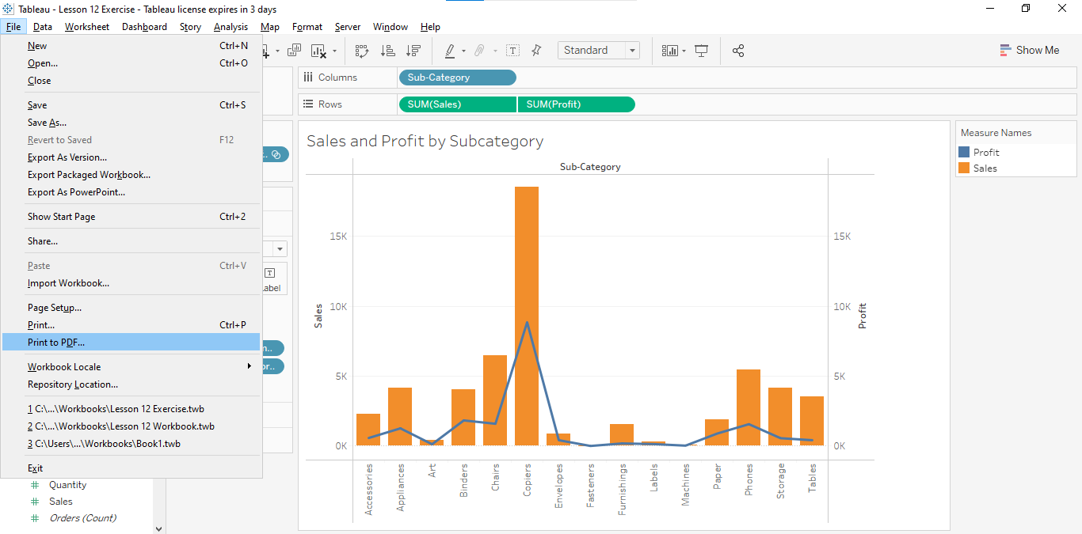

1. In the **Print to PDF** window, under **Range**, click on **Entire workbook**

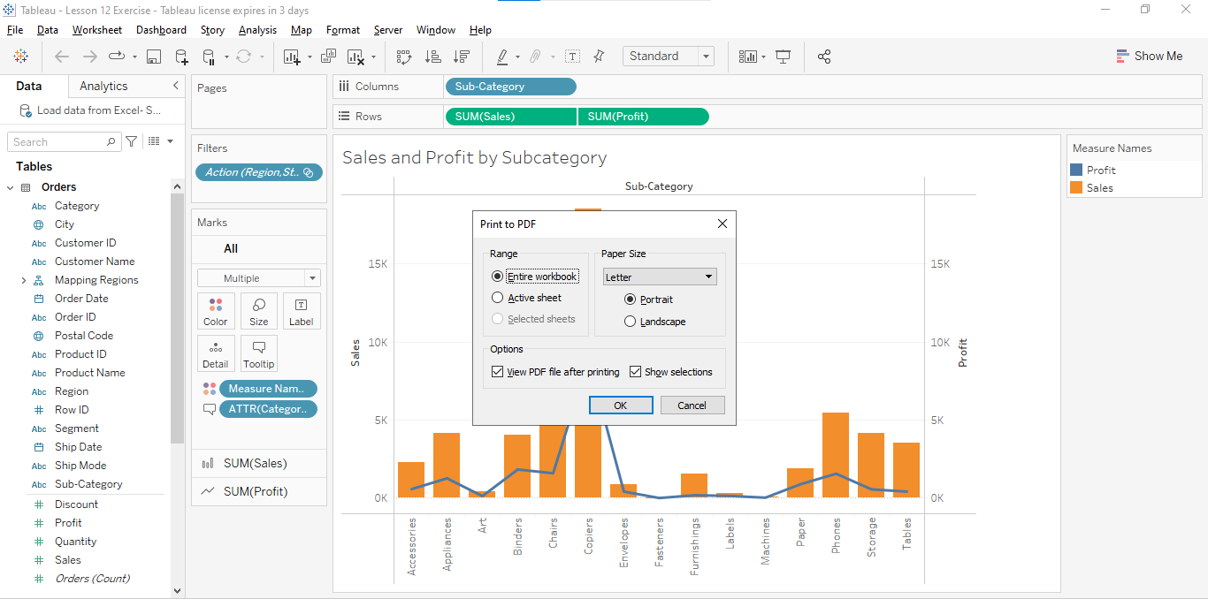

1. In the **Save PDF** window, browse through **Documents\My Tableau Repository** and save it as **Retail Analysis-PDF**

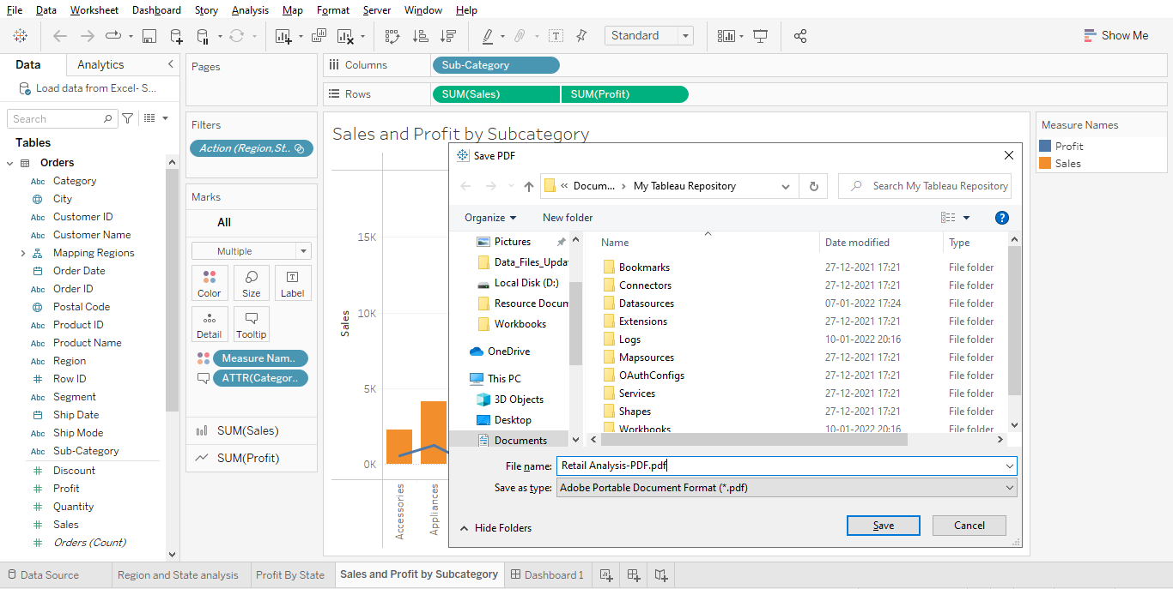

1. Save and close the workbook